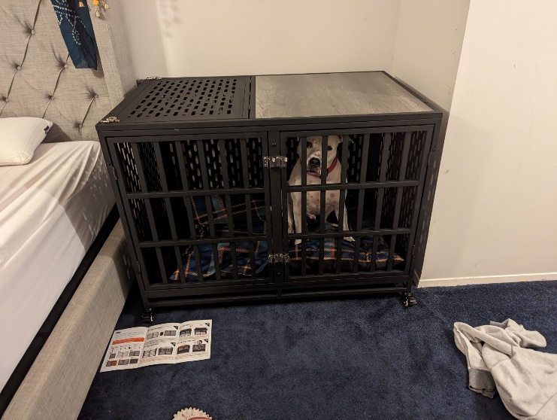**Crate & Confinement training**

## I will go over some common questions and concerns in the following blog. There will be a common underlying theme, and that is to set your dog up for succuss. It is always better to prevent undesirable behavior by managing the situation and showing your dog what is expected than to correct behaviors that the dog did because of lack of supervision. Additionally, by preventing your dog from practicing certain undesirable actions, you are not allowing that behavior habit to occur.

# **What does being crate trained mean?**

Having your dog crate trained means that they are comfortable being in a crate for a reasonable period of time either on a regular basis or temporarily for certain situations. Specifically, this means the dog will willingly enter the crate when prompted to by a cue; “go to your crate” or with specific environmental occurrences; doorbell rings, visitors arrive, dinnertime, etc. Additionally, many dogs may benefit from the option of having the crate open and available for the dog to choose to rest inside their crate.

# **What does being crate trained NOT mean?**

It does not mean your dog is trapped in a crate for a lengthy amount of time on a regular basis. A crate or other confinement area should NEVER be used as punishment. Any negative associations with a crate should be avoided, this includes excessive use of the crate & using the crate for unpleasant experiences solely. Being crate trained does not actually mean that a dog is even routinely in a crate, it just means they are COMFORTABLE when the occasion arises to be crated, or otherwise confined; kenneled, gated off, etc.

# **What are the benefits to having your dog crate trained?**

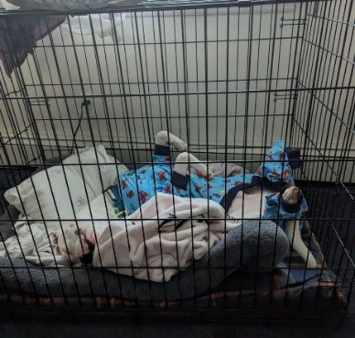

If your dog is conditioned to the crate properly, they will be relaxed and comfortable when inside their crate in a variety of situations and locations. If your dog periodically or regularly goes into his crate for fun time, it will also not indicate something unpleasant or stressful is about to happen. When crating is necessary or beneficial, your dog will not be stressed when in a crate. Some dogs may still experience some stress in certain situations, but it will be minimal and one less layer of stress at the moment. This can allow for more freedom for both the dog and the owners for a number of reasons.

# **What are some situations a dog may need to be crated?**

There are many situations where a dog may need to be crated (or kenneled) and several situations where it may not be “needed”, but beneficial. Here are some examples:

* A young puppy or adolescent dog that is not fully housetrained or destructive when unsupervised **\*NOTE**\* crating should be used to prevent accidents & not used as punishment because of accidents including destructive behaviors
* When used after an accident the crate is then a punishment
* By not crating your dog and preventing accidents, you are allowing the dog to practice those undesirable behaviors ***practice makes perfect….
* Examples of undesirable behaviors that can also be very expensive to treat and dangerous:
* Chewing furniture, baseboards, wires, carpets, etc.
* Scratching and digging at inappropriate surfaces
* Ingesting non edible items resulting in foreign body obstruction or poisoning
* Soiling throughout the house
* Nuisance barking at windows, doors, or when delivery personal approach ***This can lead into barrier frustration and even aggression generalized toward specific types of people
* Demand barking toward owners that give in due to being distracted (think about how your kids would ask for things while you were on the phone)
* Door dashing and unruly behaviors such as jumping up and other forms of overexcitement when guests arrive
* A senior dog that that is at risk of falling or wandering \***NOTE\*** it can be especially traumatizing for an older dog with cognitive decline to be crated if they have not been accustomed to proper crate training
* A senior dog that is at risk of injury when given free roam unsupervised may benefit more from other forms of confinement such as being gated off in a safer area
* Recovery from illness or injury where limited activity is needed
* Vacations, emergency evacuations, relocation or moving situations:
* Extended transportation needs - especially for small dogs as they may be allowed on airlines, larger dogs for train/van/cargo transportation
* Hotels rooms – even pet friendly hotels often require dogs to be crated unsupervised
* Visiting extended family or friends – due to change in household dynamics it may be needed or beneficial for your dog to be crated in your house or when visiting others
* Boarding needs – many vet and other boarding facilities including private homes will require an animal to be crated periodically

Temporary situations that may be best managed to prevent injuries to your dog or visitors – especially if your dog struggles with any of the behavioral concerns listed:

* Visiting children, seniors, or adults uncomfortable around dogs
* Visiting dogs or other pets
* While caring for a family member with an illness or injury
* When work is being done around house; construction, cleaning, emergency repairs
* When other people may come and go from house such as babysitters, home health aides, landlords, even dog walkers

Dogs that have the following Behavioral concerns:

* Dogs that guard their food, toys, bones, furniture, resting spots, or caregivers
* Dogs that are reactive or aggressive toward visitors or strangers
* Dogs that are reactive, potentially aggressive toward other dogs or pets, or become competitive over resources in the company of other dogs
* Dogs that are sensitive to touch, certain motions, and/or high arousal activities
* Dogs that have an extreme reaction to sleep startle

Keep in mind life is unpredictable and doesn’t always go as planned. Households’ changes, families expand & decrease suddenly. Illness, injury, divorce, & economic loss can cause a sudden household change where is may be appropriate for your dog to be crated periodically, or even routinely.

In the event your dog needs to be rehomed, or even relinquished to a shelter, the chances of a positive outcome are much higher in a dog that can tolerate crating and other forms of confinement without further stress.

Having worked in various shelters and rescues, I can say definitively that a dog that will not tolerate being crated or kenneled has a far worse outcome than those that can.

# **What are some things to be cautious about with crates?**

Crates should always be placed in a safe area that is temperature controlled, away from excessive noises, sights, and strong odors. Dogs should always have access to fresh, clean water unless it is being withheld for medical purposes. The crate needs to be large enough for the dog to sit up, lie down, stand, and turn around comfortably. Dogs should have toys and chew items appropriate for their age that they have proven unlikely to eat and ingest. Food dispensing items should be sturdy and large enough for the dog and be designed for a low activity/slow feed routine. Bedding should be provided as appropriate. IF covering crates, make sure there is enough air flow, it is a rare situation that a crate must be fully covered, and when so it should be for a brief period of time. Dogs should not be in their crates unsupervised with harnesses and any collars that can tighten or are too loose, loose collar tend to get snagged more often that well fit ones. Also use caution with tags dangling as they may get caught in the slats of an airline crate or a metal crate.

# **What should I do with a crate I do not use regularly?**

Like any other training exercise, you want to occasionally brush up on it. For small dogs it is often practical to store in a closet and pull out for random use and special occasions. Perhaps keep in your car for car rides and when visiting others. For larger dogs and crates, you may choose to store it away from your living space and bring it out occasionally, or you may store it in a lower traffic but not fully isolated area. Some people, like myself have a crate set up in a spare bedroom covered and the top is used as a table top. The crate can be used for occasional storage or kept open for doggie guests.

## **What do I do if my dog hates the crate?**

An in-person consultation with a CCPDT or IAABC certified trainer or behavioral consultant is best to formulate an appropriate Counter Conditioning plan or alternative strategies. Certain cases that involve extreme anxiety such as Separation Anxiety are best supervised by a board-certified Veterinarian Behaviorist an/or a Certified Separation Anxiety Trainer (CSAT).

**Summary**

Dogs should not be crated excessively, and most dogs do not need to be crated routinely. Crates and other forms of containment should never be used as punishment. It is important for a dog to be comfortable in a crate when the situation arises!

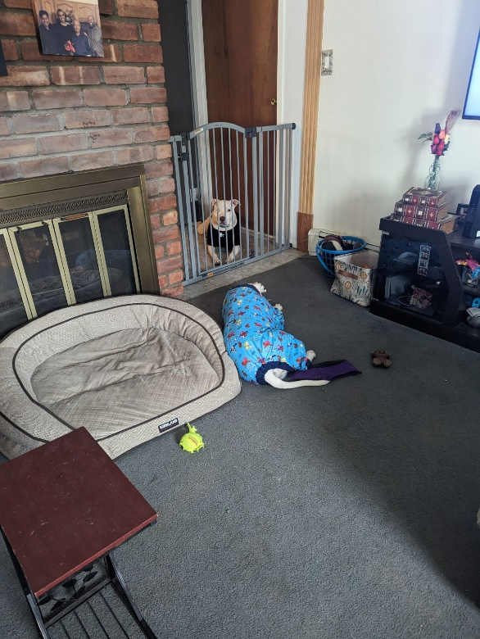

These 2 former clients of mine now live an extraordinary life together, partly due to the use of crates for managing locations where they were having conflict over competitive resources. Additionally, the use of gates

